First page

**About us History Major chosen in Scotland Sponsor working opportunity Search**

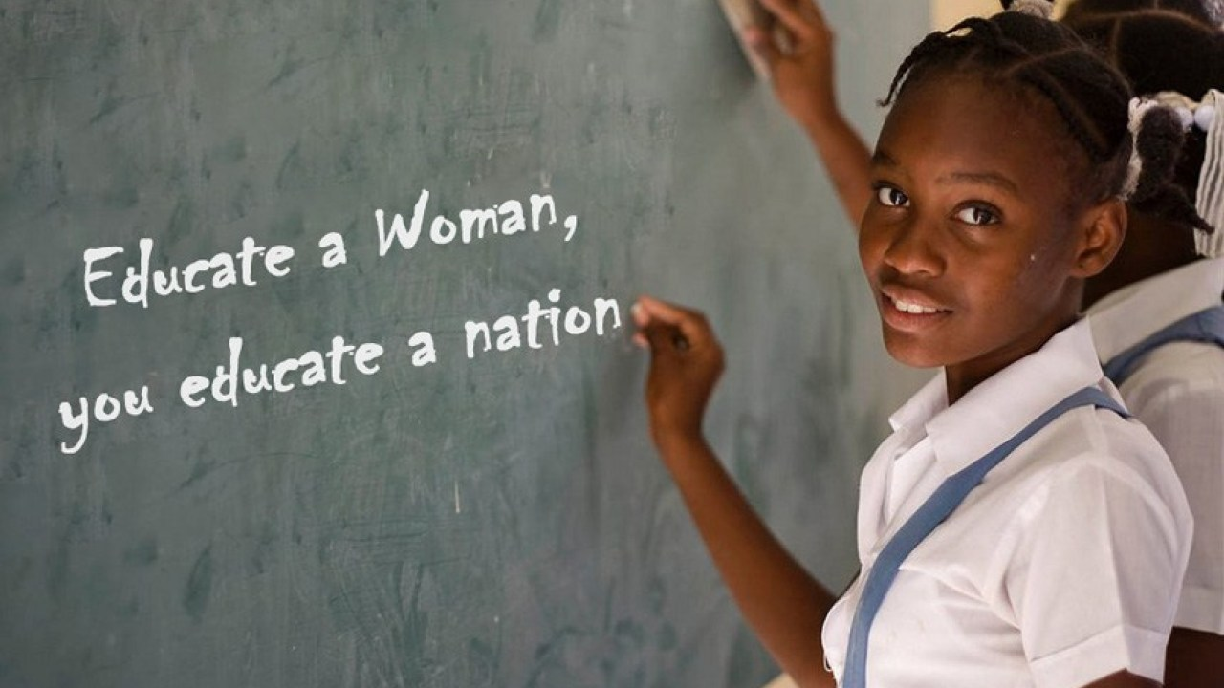

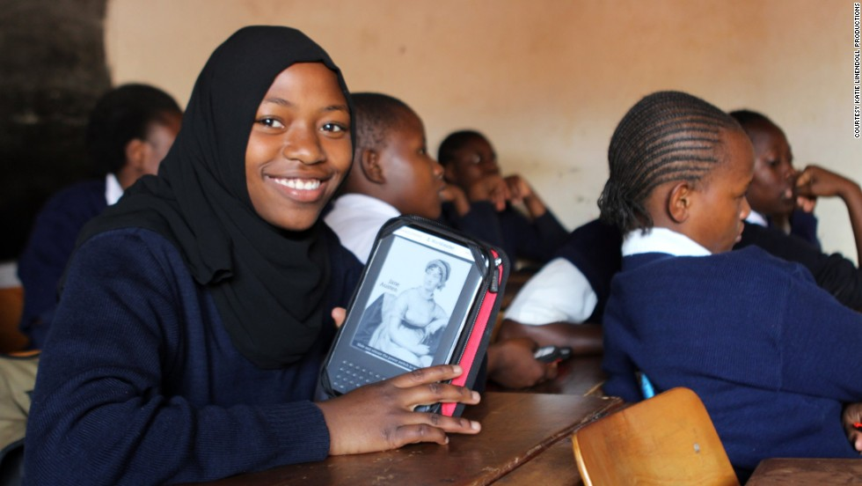

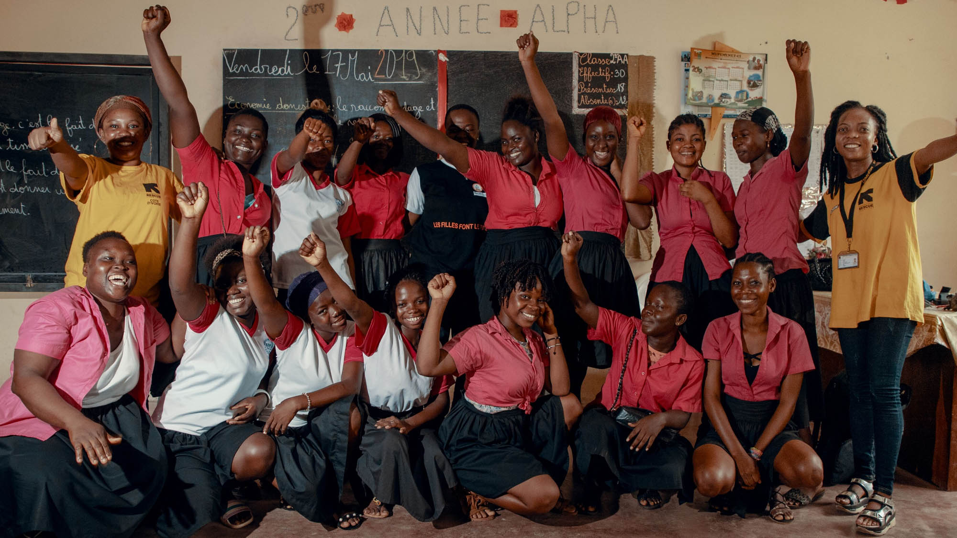

Do you desire to change your destiny through education? Contact us!

M&W Camp is a well-known international organization who focused on helping female students from developing countries to study in Scotland. We have already helped 3200 females from 25 developing countries in South Africa, South America and Asian countries during last 10 years. We also provide major consultation help, financial support and internship opportunities for these students. If you want to know more details about our project, click on history.

Picture website:

[https://i0.wp.com/www.afterschoolafrica.com/wp-content/uploads/2015/11/Educate-a-woman-girl.jpg?fit=861%2C574&ssl=1&resize=1280%2C720](https://i0.wp.com/www.afterschoolafrica.com/wp-content/uploads/2015/11/Educate-a-woman-girl.jpg?fit=861,574&ssl=1&resize=1280,720)

<https://cdn.cnn.com/cnnnext/dam/assets/140818165010-worldreader-3-horizontal-large-gallery.jpg>

<http://ida.worldbank.org/sites/default/files/carousel/afr-girls-2000-1125.jpg>

History

2009/01 M&W Camp was founded in London UK.

2009/05 M&W Camp set 3 brunch offices in North Africa

2012/04 M&W Camp set 5 brunch offices in West Africa and East Africa

2013/09 M&W Camp set 2 brunch offices in South Asia

2015/02 M&W Camp set 5 brunch offices in South America

**Working opportunity**

* **United Nation working opportunity**

Application date: Feb 05-June 30 2020

Duration: 3 months

Location:New York

Background: international relations, international development, international laws etc.

Register website:

<https://careers.un.org/lbw/Home.aspx>

* **International Internships in Madrid with The Intern Group**

Application date: March 2020

Duration: 1-6 months

Location: Spain

Background: international relations, Communications Conservation and Preservation Criminal Justice Culinary, Arts Design Economics etc.

Register website:

<https://www.gooverseas.com/internships-abroad/spain/intern-group/31663>

* **National Security and International Affairs Research Internship**

Application date: Spring 2020

Duration: Fall 2020

Location: Washington, DC

Note in the message box on the application page if you have particular interest or a background in any or all of the following areas.

China & East Asia

South China Sea

US-Israeli relations

General International Affairs

Register website:

<https://www.hudson.org/about/employment/57-national-security-and-international-affairs-research-internship-spring-2020>

* **Internship, Foreign Affairs, Editorial, Spring 2020**

Application date: Spring 2020

Duration: 3 months

Location: New York

CFR internships are paid, require a 14-18 hour commitment, and are filled on a rolling basis.

Qualifications

Undergraduate student with concentration in political science, international affairs, journalism, or related field

Demonstrated interest in journalism and online publishing; past relevant internship experience preferred

Strong writing, editing, and Internet skills

Knowledge of Drupal is a plus

Register website:

[https://careers-cfr.icims.com/jobs/1558/internship%2c-foreign-affairs%2c-editorial%2c-spring-2020/job?mobile=false&width=1110&height=500&bga=true&needsRedirect=false&jan1offset=480&jun1offset=480](https://careers-cfr.icims.com/jobs/1558/internship,-foreign-affairs,-editorial,-spring-2020/job?mobile=false&width=1110&height=500&bga=true&needsRedirect=false&jan1offset=480&jun1offset=480)

Diversity Affairs Paid Internship

Application date: Oct 15-Nov 15 2020

Duration: 205 hours

$7.25 an hour - Internship

Location: Salt Lake city

MINIMUM QUALIFICATIONS

Candidates who study in a related field and are self-motivated will be considered. Must have an interest in diversity issues. Basic English writing skills and computer knowledge are required. Second language a plus, but not required. Students with a focus in Social Sciences, Political Science, Communications, Marketing, Social Work, International Studies, or Language Studies preferred; but all applicants welcome.

Register website:

[https://recruiting.adp.com/srccar/public/RTI.home?r=5000544336906&c=1210501&d=External&rb=INDEED&sid=5#/](https://recruiting.adp.com/srccar/public/RTI.home?r=5000544336906&c=1210501&d=External&rb=INDEED&sid=5" \l "/)